

**Tuesday, November 8, 2016**

Reading: read for 10 minutes

Math: Lesson 2 subtraction stories – Due Thur. 11/10

Spelling: study spelling

**Monday, November 7, 2016**

Reading: Read for 10 minutes

Math: Lesson 2 subtraction stories – Due Thur. 11/10

Spelling: study spelling

WEEKLY HOME PRACTICE SHEET: 11/7 – 11/10

**Thursday, November 10, 2016**

Reading: read for 10 minutes

Math: none

Spelling: practice test – test tomorrow!!

**Wednesday, November 9, 2016**

Reading: read for 10 minutes

Math: Lesson 2 subtraction stories – Due Thur. 11/10

Spelling: study spelling

**Spelling Words:**

then

them

this

that

path

with

ten

get

said

was

Challenge Words

election

president

**Robust Words:**   
applauded

chatty

gather

**High Frequency Words:**

don’t

her

line

Mr.

new

says

water

This sheet should remain in your child’s take home folder. I will check to make sure it is signed each day. If there is a reason why your child has not completed their work, please write a note on that day. Thank you!

**SPECIAL SCHEDULE:**

Monday – Music

Tuesday – Art

Wednesday – Gym

Thursday – Gym

Friday – Library

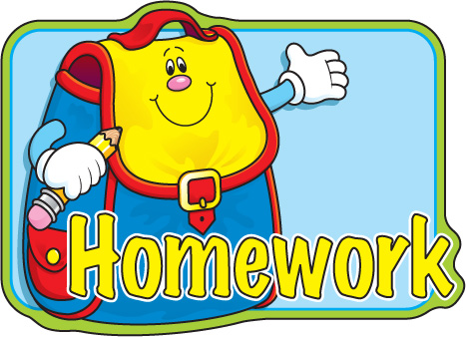

**Special Notes:**

**NO SCHOOL Tuesday!!!** Please send back your conference form ASAP if you have not already done so. Veterans Day assembly is Friday at 9:30.

Please sign

Please sign

**NO SCHOOL**

Please sign

Please sign

**\*pack library books**